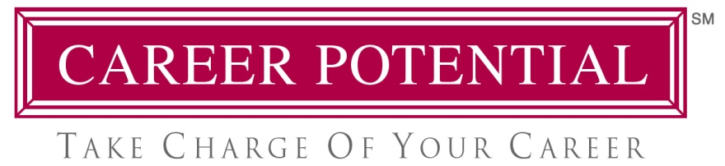

The Power of “Pull Marketing” in Your Job Search

When searching for a new job, would you rather “chase after employers,” or have employers “chasing after you?” The choice is YOURS, and you CAN conduct your job search in such a way that employers will take the first step by reaching out to you.

Traditional job search methods include sending-out resumes, applying for jobs online, attending job fairs, contacting employers and recruiters, and of course - networking. All of these tasks, collectively, fall under the heading “Push Marketing.” This is because you’re “pushing” your message, hoping that someone will take notice. Even if you do make contact, however, you’ll still have to “convince” the employer of your worthiness. This is the downside of “Push Marketing.”

But when employers perceive you as an expert and discover your credibility “on their own,” they’ll tend to feel pulled toward you and even pursue you. This is the primary benefit of “Pull Marketing.”

YOU can be known as an expert, regardless of your professional background or employment level. The process begins with a fundamental shift in attitude, assumptions and behavior. To succeed with “Pull Marketing,” you’ll need to:

- Stop acting like an applicant, and start acting more like an expert
- Stop behaving like a candidate, and start behaving like a consultant
- Stop being a job seeker, and start being a problem solver
- Stop making it all about you/your needs, and start making it all about them/their needs

Don’t miss this unique seminar, where you’ll learn how to make this critical shift. You’ll discover the specific tactics, strategies and tools to master “Pull Marketing” in your job search and long-term career management.

Your shift to “Pull Marketing” may require some extra time and effort up-front, but the results will be worth it. This innovative approach offers you greater control over the entire hiring process. Best of all, you may never have to search for another job in your life!

____________________________________________________________________

Ford R. Myers is an award-winning Career Coach and Certified Retirement Coach. He is author of the best-seller, “Get The Job You Want, Even When No One’s Hiring.” Ford’s firm, Career Potential, LLC, helps clients take charge of their careers, create the work they love, and earn what they deserve! He has held senior consulting positions at three of the nation’s largest career service firms. Ford’s articles and interviews have appeared in thousands of magazines, newspapers, web sites, television and radio networks. He has also conducted presentations at hundreds of companies, associations and universities. Learn more at www.careerpotential.com.

